Student / Mentor Agreement NYSAFP
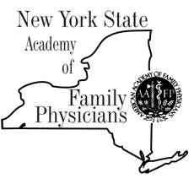

OVERVIEW
This agreement is between the medical student (mentee) and the NYSAFP member (mentor). • Students are required to submit this form to mentor and kelly@nysafp.org within one week of mentor match. Each mentee-mentor pair is unique and will have its own working style. However, minimum expectations include:
STUDENT MENTEE’S RESPONSIBILITIES
Student must be NYSAFP member • Work with mentor to set
mutual expectations of the mentoring relationship • Give the
mentor 2-3 goals you wish to gain from the mentor / mentee
relationship • Set up first meeting within 2 weeks
of mentor match.
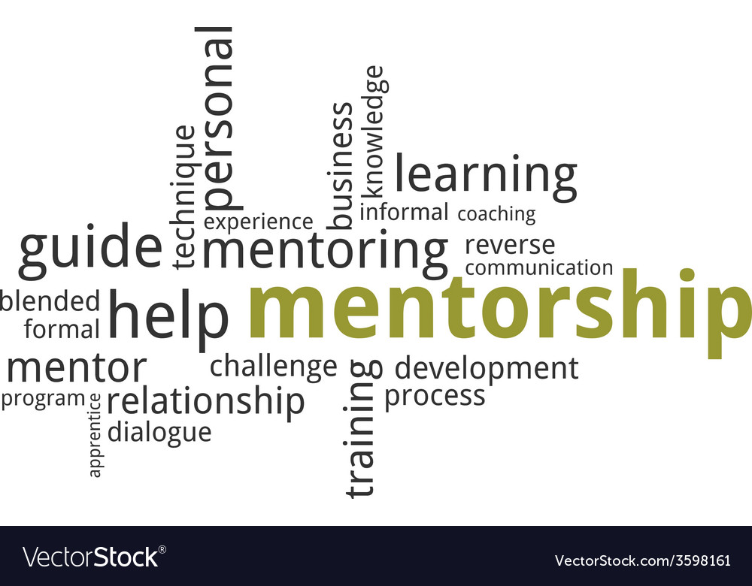
MENTOR’S RESPONSIBILITIES (when appropriate)
Work with student to set mutual expectations of the mentoring
relationship • Help student set specific, achievable goals,
Monitor progress toward any proposed objectives • Provide
information about Family Medicine, mentee’s career; Introduce student to key people and/or groups • Provide guidance and constructive feedback to the student • Be willing to allocate time and attention to the student to provide them a positive and meaningful experience. •Contact NYSAFP with any concerns.
MATCH INFORMATION
MENTEE CONTACT INFORMATION:
Name: Lewis Wong
email:
school: year:
location:
Although you will be able to expand upon these goals with your mentor, please list 2-3 goals you wish to gain from the mentee / mentor match.
- ______________________________________________________________________________
- ______________________________________________________________________________
- ______________________________________________________________________________
MENTOR CONTACT INFORMATION
Name:
email:
location:
DATE June 24, 2020

